Android SDK specification
for PTS-2 controller

Review date: 4 September, 2025
Revision number: R09

Approved by: _______________ Date: ___________________

Technotrade LLC

REVISION HISTORY 3

INTRODUCTION AND SCOPE 4

AUTHENTICATION 5

LAYERS OF COMMUNICATION 6

GENERAL NOTES FOR COMMUNICATION 6

SETTINGS 8

APPLICATION EXAMPLE 9

GENERAL REQUESTS AND RESPONSES 14

REVISION HISTORY

REV | DATE | BY | SECTION | DESCRIPTION
R01 | 11.04.2024 | Dmitry Vasyliev | All | First alpha release
R02 | 3.08.2024 | Dmitry Vasyliev | All | First alpha release. The test application was added.
R03 | 8.08.2024 | Dmitry Vasyliev | Example application, documentation | Second release.
R04 | 23.09.2024 | Dmitry Vasyliev | SDK  Example application | ObserverInterface was renamed to IObserver  Settings issue(settings loading only at application startup) was fixed.  HTTP/HTTPS switcher was added to the settings screen
R05 | 25.10.2024 | Dmitry Vasyliev | Documentation  SDK  Example application | Updated test app screenshots and description  Bugfixes, initialization  Fragments navigation was changed and improved  Some example application methods were renamed and classes added/deleted
R06 | 06.02.2025 | Dmitry Vasyliev | SDK | Request headers were changed  HTTP client logic was improved
R07 | 21.05.2025 | Dmitry Vasyliev | SDK | A fix was applied to the pump control test application: pump selection now works correctly for specific pump configurations.
R08 | 29.07.25 | Dmitry Vasyliev | SDK  SDK, Example application  SDK | ProbeMeasurements.getTankFillingPercentage() returns int  CriticalHighProductAlarmHeight field was added for TanksConfiguration response  GetFirmwareInformation request was fixed  PumpSetAutomaticOperation, PumpSetLights requests were fixed
R09 | 04.09.2025 | Dmitry Vasyliev | SDK  Example application  Documentation | ReportGetPumpTransactions DateTime property parse was fixed  The example application was almost completely rewritten to follow wizard-like business logic. App stability has been improved  The documentation has been updated to include an overview of the new test application

INTRODUCTION AND SCOPE

Android SDK for PTS-2 device represents a library pts2. The library minSdkVersion is 24.
Thee library is native and using Java without using of NDK.
This document is intended to be used by OEMs who wish to interface to the PTS-2 controller. The PTS-2 controller Ethernet link allows a master device to remotely control operation of petrol, diesel, LPG and CNG dispensers and automatic tank gauge systems.
Technotrade LLC hereby permits reproduction of this document as may be required by any of our customers or OEMs wishing to use it.
This document has been carefully prepared and is believed to be accurate. However, Technotrade LLC, its employees and its agents do not assume responsibility for its use either directly or indirectly. Technotrade LLC reserves a right to make changes to this document at any time without notice. Prospective users of this document should contact Technotrade LLC at the time they wish to implement this protocol on their products to become aware of any updates that may apply.
Complete information regarding PTS-2 controller can be found on its web-page: http://www.technotrade.ua/pts2-forecourt-controller.html.
All technical questions regarding the PTS-2 controller are welcome to be asked on support mailbox: support@technotrade.ua. Our support team will be glad to help you.
In case if you find any mistakes, omissions in this document or have any suggestions on improvements to this document, please feel free to e-mail them our support mailbox: support@technotrade.ua. We will be thankful to you for this valuable information.

AUTHENTICATION

PTS-2 controller can use one of the following authentication types:
- digest (https://en.wikipedia.org/wiki/Digest_access_authentication)
- basic (https://en.wikipedia.org/wiki/Basic_access_authentication)

Authentication type is selected using switch 2 of configuration DIP-switch on board of PTS-2 controller:
- OFF position: digest authentication
- ON position: basic authentication

PTS-2 controller accepts a message only if it contains authentication information of a user, which is valid and present in configuration of PTS-2 controller otherwise the response will be Result.UNAUTHORIZED_ERROR

LAYERS OF COMMUNICATION

Android SDK for PTS-2 controller provides request classes for communicating with PTS-2 device. It uses jsonPTS communication protocol to communicate with PTS-2 device. jsonPTS communication protocol is based on HTTP protocol version 1.1 and messages are always transmitted using POST request.
You can find details about jsonPTS in document “jsonPTS protocol for PTS-2 controller”.

GENERAL NOTES FOR COMMUNICATION

1. PTS-2 device allows to receive requests queue to speed up communication. The following example will illustrate how to use requests queue:

public synchronized boolean getDataThatNeedAtStart() {
if (isOpened() == false) {
notOpened();
return false;
}

// ClearRequestsQueue will clean requests queue
Result result = mDevice.clearRequestsQueue();

//The function will request a configuration identifier
if (result == Result.SUCCESS) {
result = mDevice.getConfigurationIdentifier();
}

//another methods that we want to request in the same queue
if (result == Result.SUCCESS) {
result = mDevice.getDateTime();
}

if (result == Result.SUCCESS) {
result = mDevice.getMeasurementUnits();
}

if (result == Result.SUCCESS) {
result = mDevice.getPumpsConfiguration();
}

if (result == Result.SUCCESS) {
result = mDevice.getFuelGradesConfiguration();
}

if (result == Result.SUCCESS) {
result = mDevice.getPumpNozzlesConfiguration();
}

//Requests queue will be executed
if (result == Result.SUCCESS) {
result = mDevice.executeRequestsQueue();
}

if (result != Result.SUCCESS) {
handleError(result);
}

return result == Result.SUCCESS;
}

Please note that this method contains the “synchronized” keyword.

2. A response for each request can be available via observer object that implements ObserverInterface and that can be registered using the following method:

mDevice.registerObserver(mDataObserver);

You can look at it in example application that included in this PTS-2 SDK.
Each member of observer is a method with name related to request name that receive two arguments:

void getConfigurationIdentifierCallback(IRequest<?> request, String result);

First one is a IRequest instance that can be converted to response type. It can be used to check id of request in requests queue or error data etc.
The second argument is response data with a type that is related to response data type. For example for GetBatteryVoltageCallback the result will be an integer value that represents a battery voltage.

3. The opening / closing of connection to PTS-2 device can be done using functions “open” and “close” of the Device object. Before running “open” method the “settings” object must be filled.

Look at project pts2TestApp for additional details.

SETTINGS

Class Settings allows to set the following settings:
- AuthenticationType — authentication type of PTS-2 device. Can be set to AuthenticationType.BASIC or AuthenticationType.DIGEST
- ProtocolSecurityType — sets the type of protocol of jsonPTS communication protocol level. Can be set to ProtocolSecurityType.HTTP or ProtocolSecurityType.HTTPS.
- Host – the IP address or host name of PTS-2 device.
- HttpPort – the port for comminucating via HTTP protocol
- HttpsPort — the port for comminucating via HTTPS protocol
- Login
- Password
- Timeout – timeout that will be used during any PORT request to PTS-2 device

APPLICATION EXAMPLE
The SDK includes an example application for the Android platform. It follows the MVVM design pattern and is event-driven.

When you start the application, you will see the home screen with two buttons at the top: “Settings” and “Connect.”
- Settings is used to configure the connection and other options.
- Connect establishes a connection with the device. This button also contains an indicator:
  - Green – connection established
  - Red – no connection or a connection error
  - Blinking – the app is trying to connect or reconnect
The menu also contains an “Extra” item, which provides utility functions.

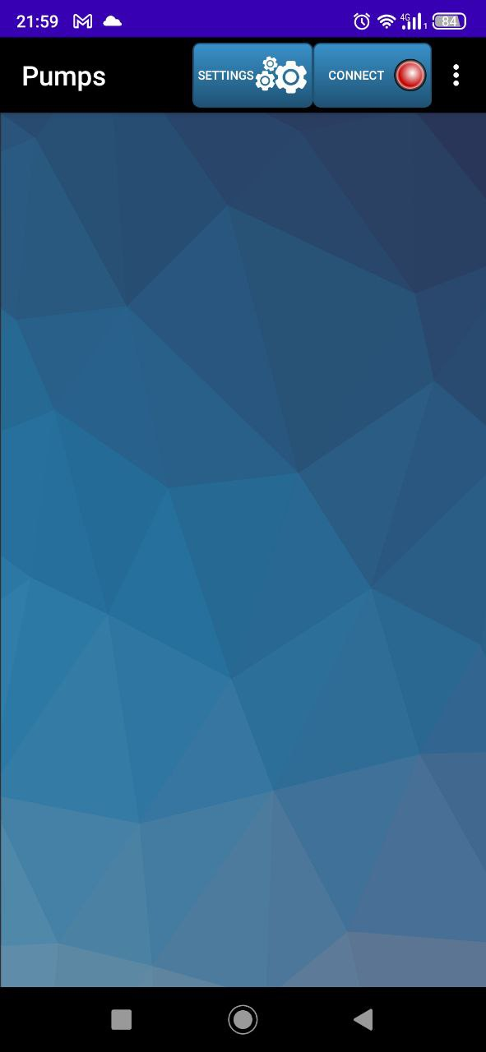

Once connected to the PTS-2 device, the “Dispensers” tab shows a list of dispensers. For each dispenser, you can see:
- Dispenser number and state
- Progress bar (if fueling is in progress)
- Nozzle number
- Fuel name assigned to the nozzle
- Volume, price, and amount
You can tap any dispenser that is not offline to open its details.
- If the option “Nozzle must be taken” is enabled, you cannot select a dispenser until one of its nozzles is lifted. In that case, the app will display a message.
- If the dispenser is already processing an order, tapping its card will open the fueling screen, where the user can stop fueling.
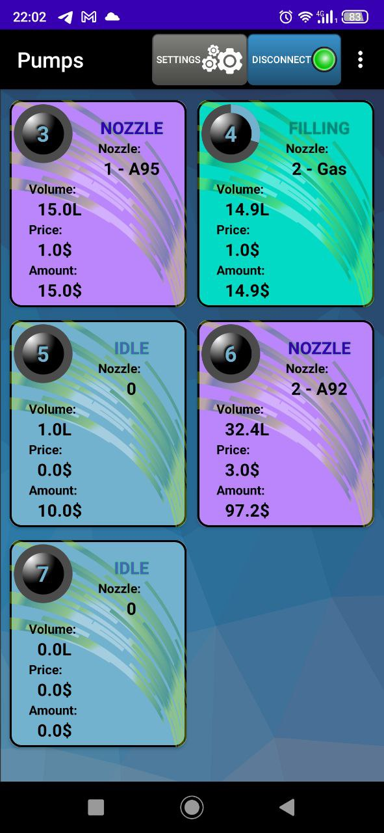

On the dispenser screen, the following elements are available:
- Dispenser status card – shows the current state of the pump.
- Nozzle card – shows the selected nozzle, its fuel type, and price. If “Nozzle must be taken” is disabled, the user can tap this card to choose a nozzle (fuel) manually.
- Dose selection cards – two cards allow choosing the fueling dose:
  - By volume
  - By amount
  - The left side (“Change volume” / “Change amount”) opens a keyboard screen where the user can enter a value. For “Change volume,” there is also a Full Tank option.
  - The right side allows quick selection of predefined values, which can be configured in Settings.
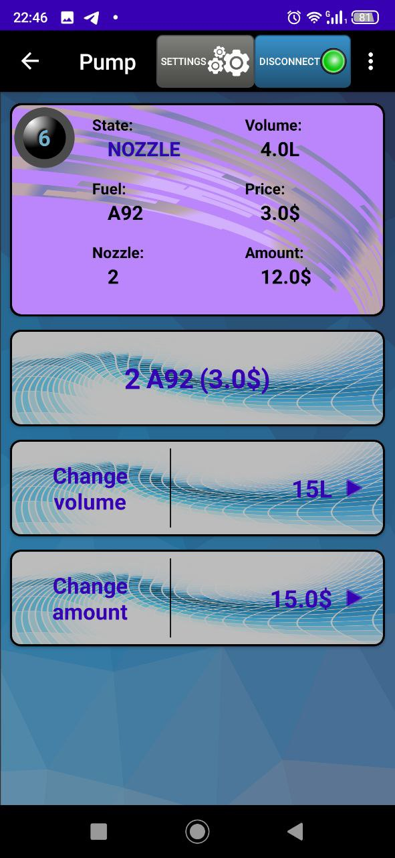
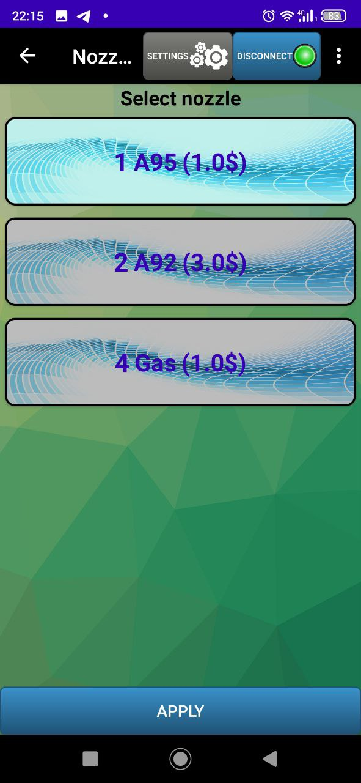

After selecting a dose (via keyboard or predefined values), a confirmation screen appears. Here, the user can review the chosen fuel and dose, then either cancel or confirm the order:
- Cancel → returns to the main dispensers list.
- Confirm → opens the fueling screen, where the user can stop fueling if needed.
During fueling, pressing the “Stop” button stops the dispenser and closes the order, returning the user to the main dispenser list. Alternatively, the user can exit early by tapping the back arrow in the action bar, which also returns to the dispenser list.
The application supports fueling on multiple dispensers simultaneously.
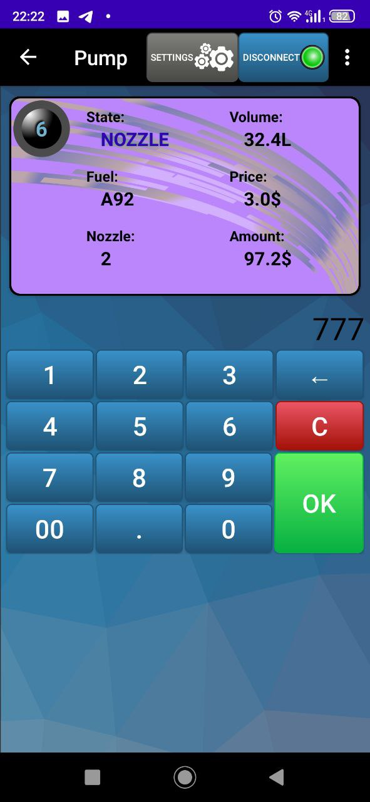
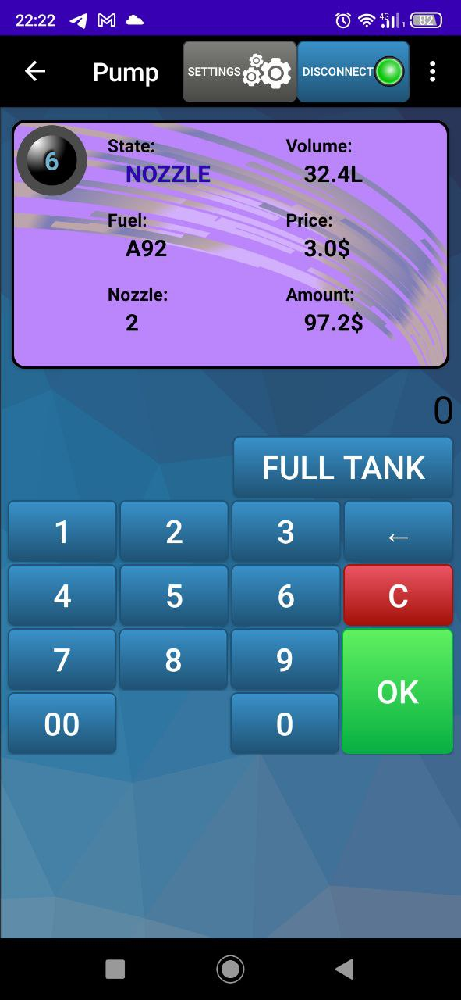

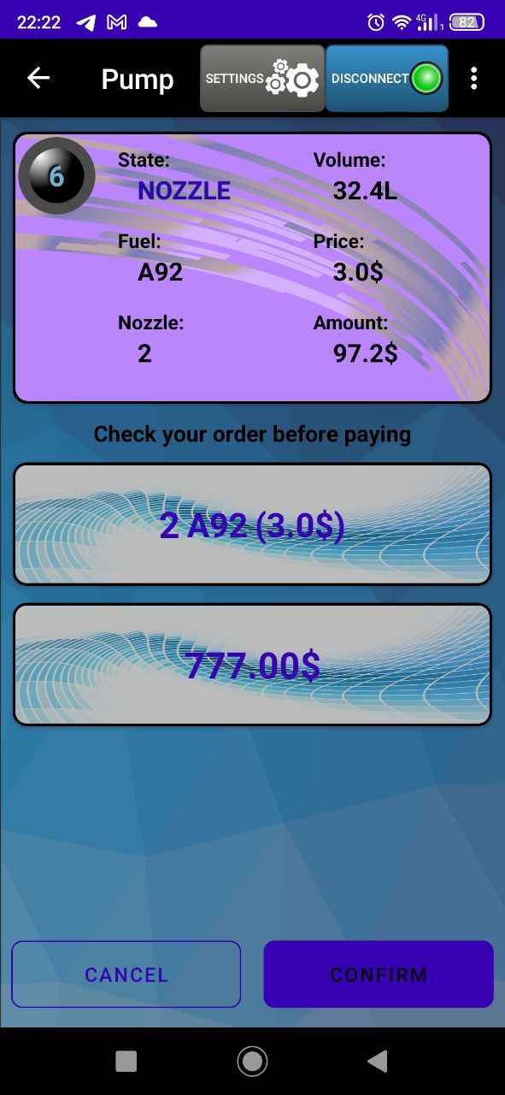
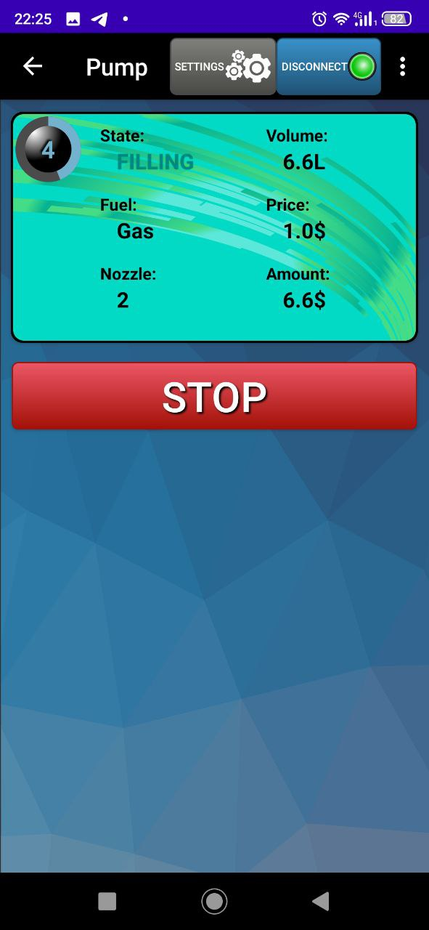

GENERAL REQUESTS AND RESPONSES
This part was removed. Please use the document “jsonPTS protocol for PTS-2 controller” that describes the low level protocol for PTS-2 device. This implementation was made close to it. In current Java implementation the some difference is that some optional fields can be not returned by request. To check it you need to call corresponding method. For example before read “ProductDensity“ property you can check that the field was filled using method “IsProductDensitySet“ property etc.

